French Meadows Dam and Reservoir
from the Western States Trail (KOP FM-1)
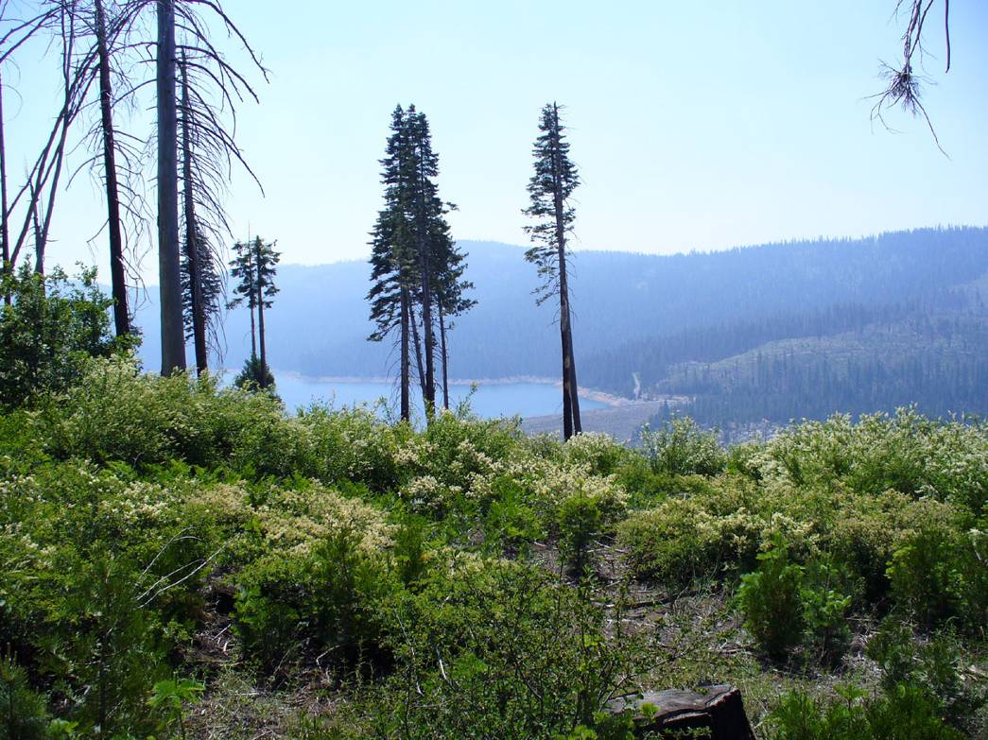
High WSE Date: 6/17/08 Time: 0958
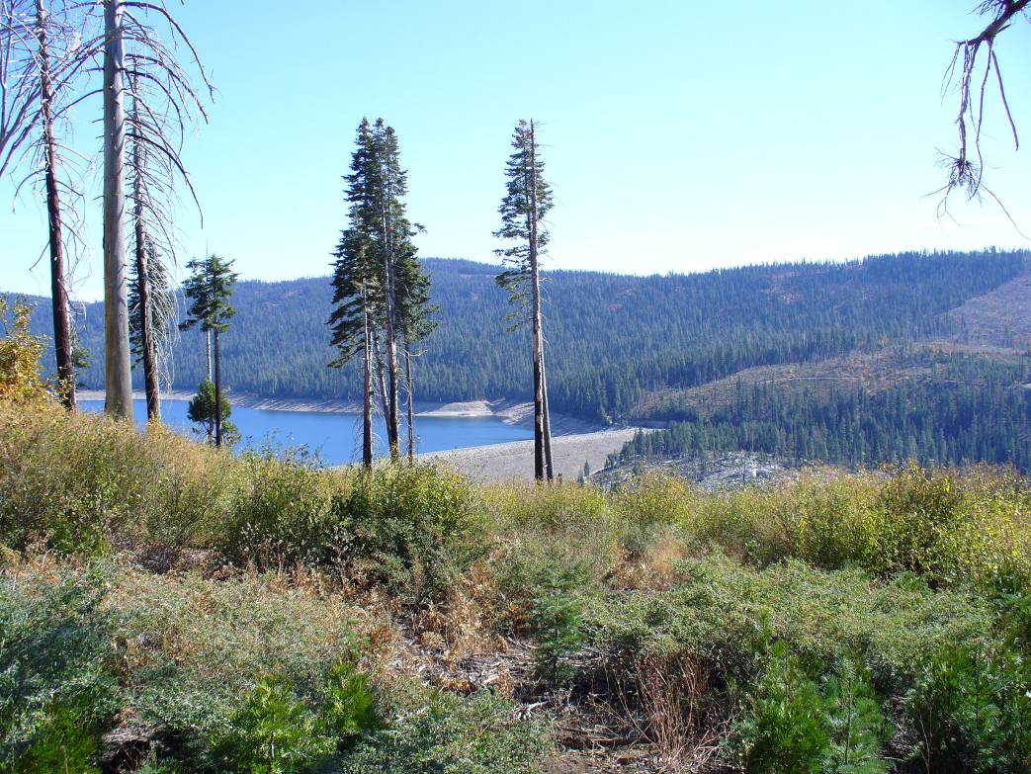
Low WSE Date: 10/24/08 Time: 1228

French Meadows Dam and Reservoir
from FR 96 (KOP FM-2)
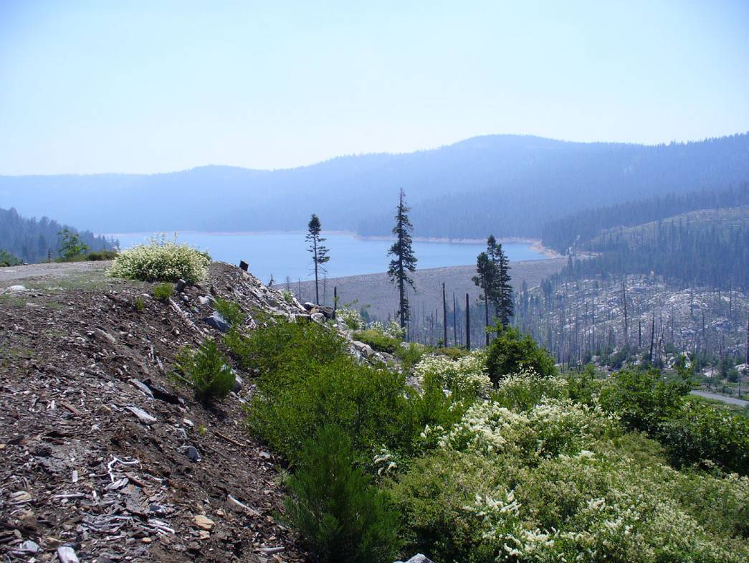
High WSE Date: 6/17/08 Time:1015
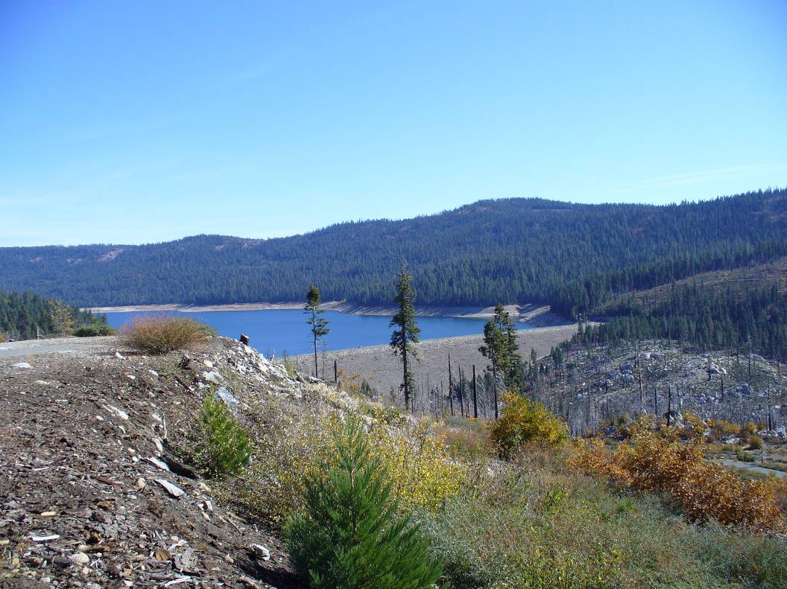
Low WSE Date: 10/24/08 Time:1217

French Meadows Dam and Reservoir
from FR 96 (KOP FM-3)
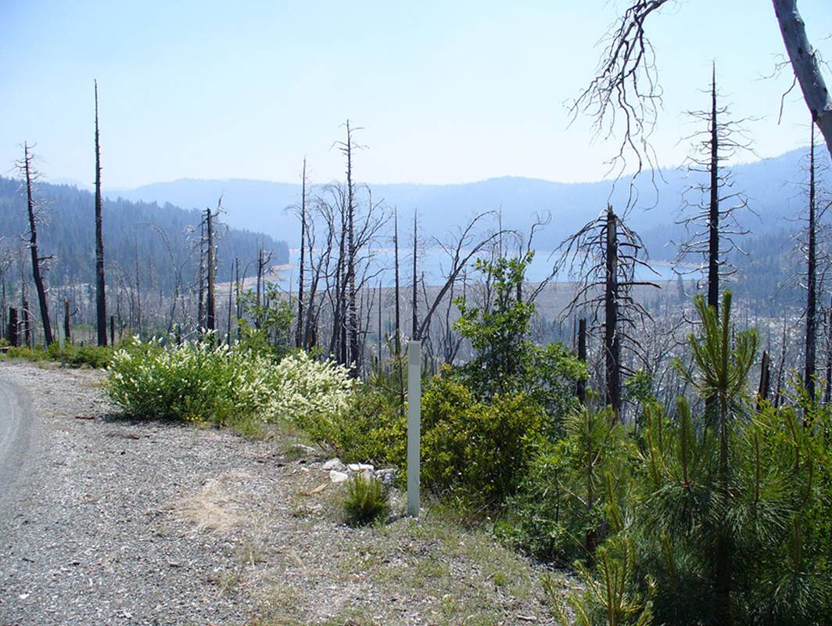
High WSE Date: 6/17/08 Time:1028
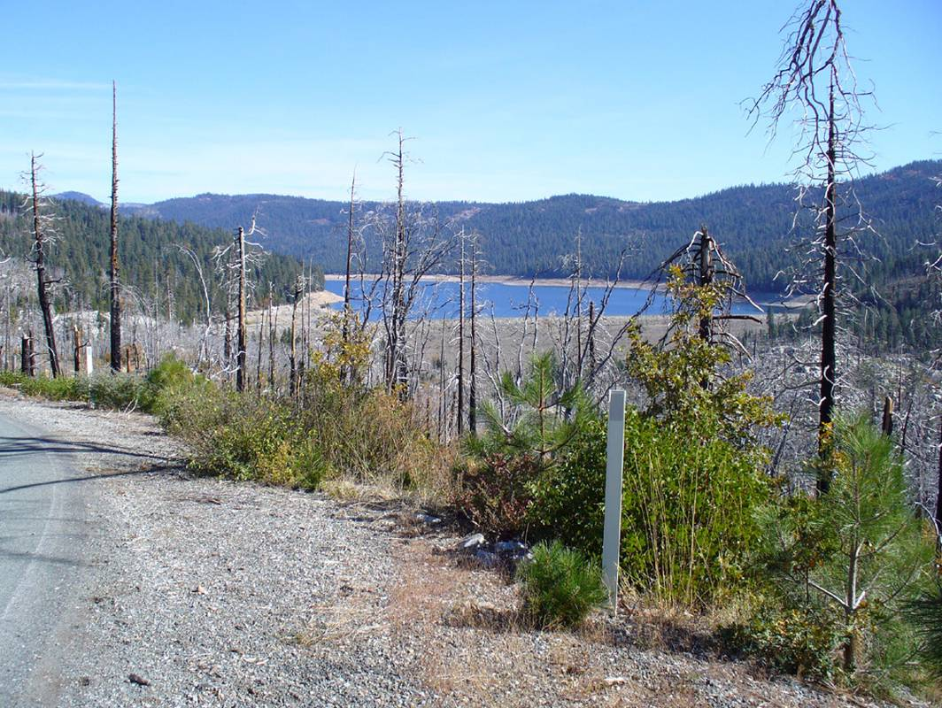
Low WSE Date: 10/24/08 Time:1213

French Meadows Reservoir from Parking Area
at North end of French Meadows Dam (KOP FM-4a)
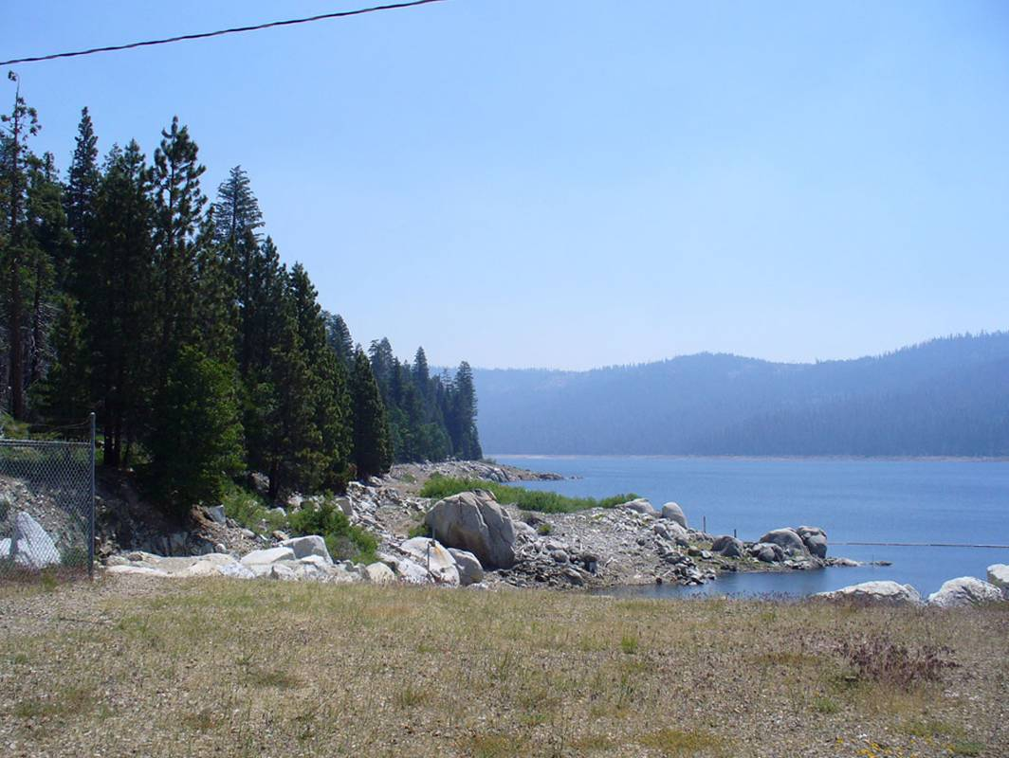
High WSE Date: 6/17/08 Time:1038
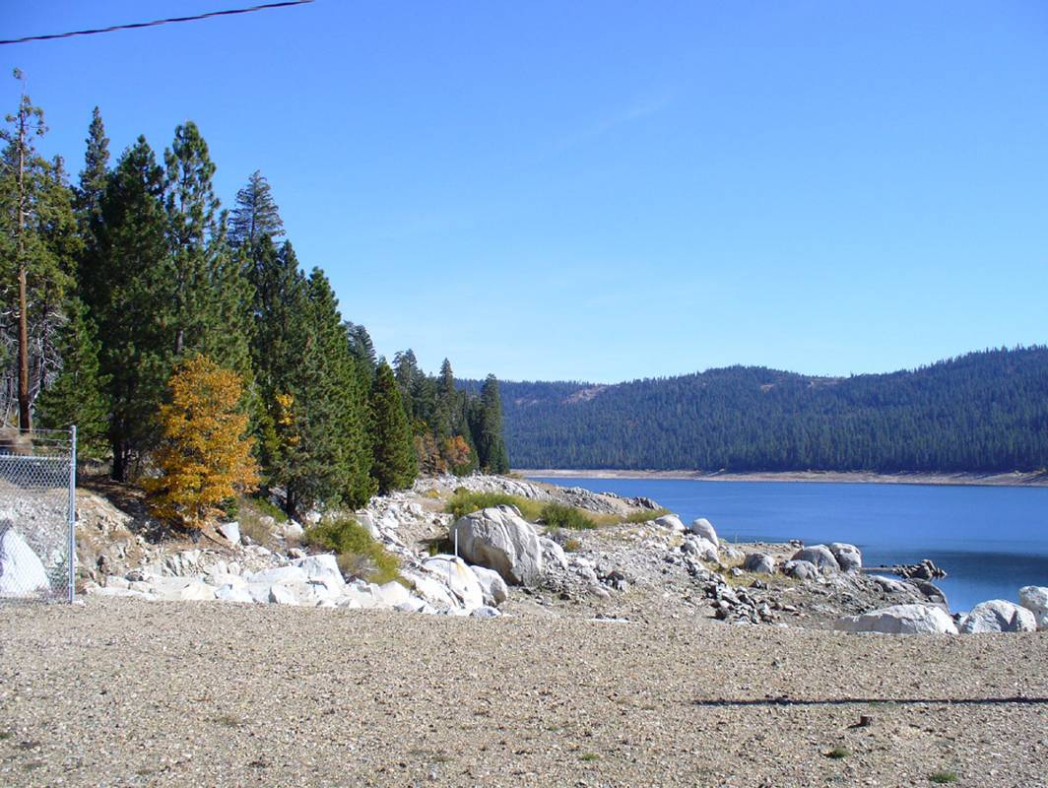
Low WSE Date: 10/24/08 Time:1205

French Meadows Reservoir from Parking Area
on North side of Dam (KOP FM-4b)
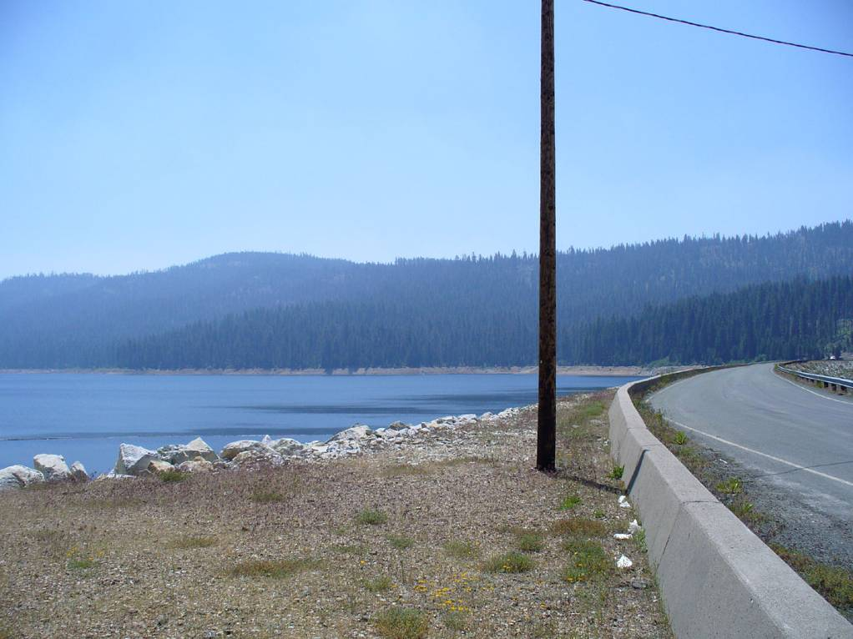
High WSE Date: 6/17/08 Time:1039
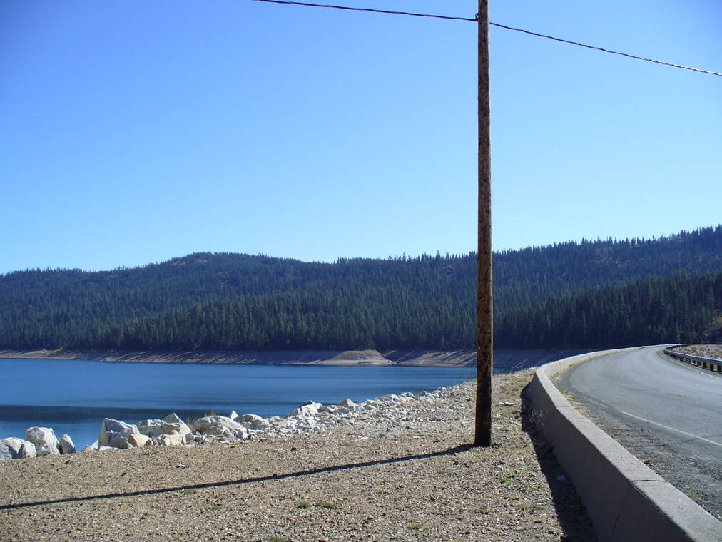
Low WSE Date: 10/24/08 Time:1206

French Meadows Dam and Reservoir looking West
from French Meadows Boat Ramp (KOP FM-5a)
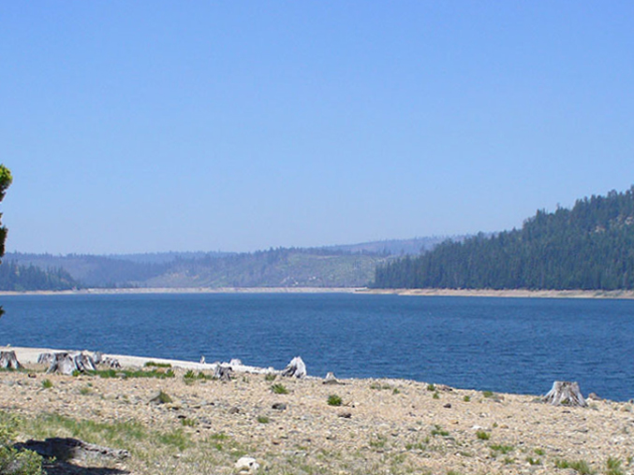
High WSE Date: 6/17/08 Time:1053
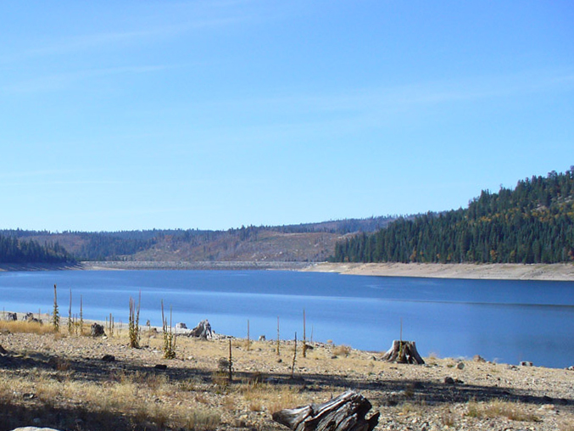
Low WSE Date: 10/24/08 Time:1151

French Meadows Reservoir Shoreline looking Northwest
from French Meadows Boat Ramp (KOP FM-5b)
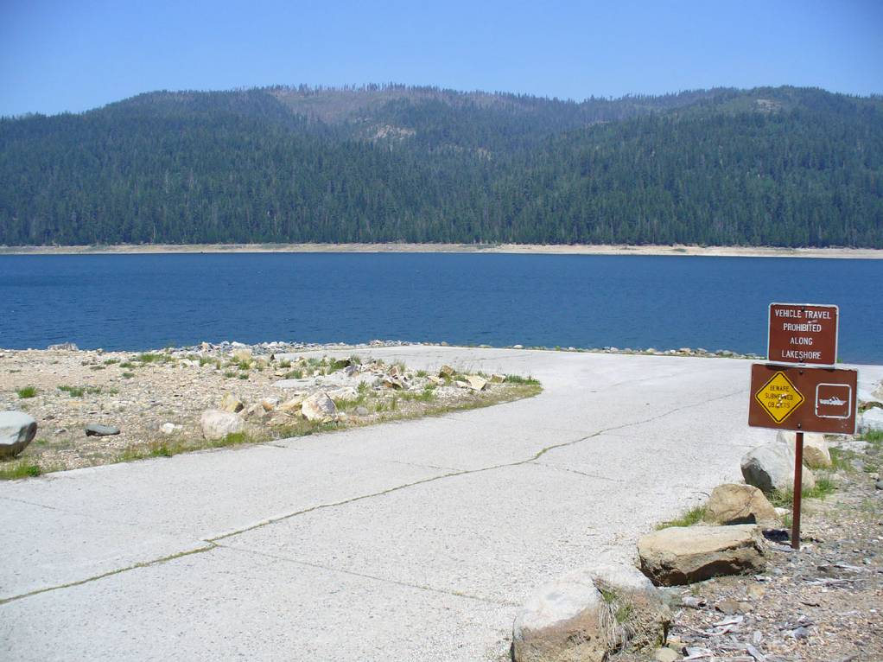
High WSE Date: 6/17/08 Time:1054
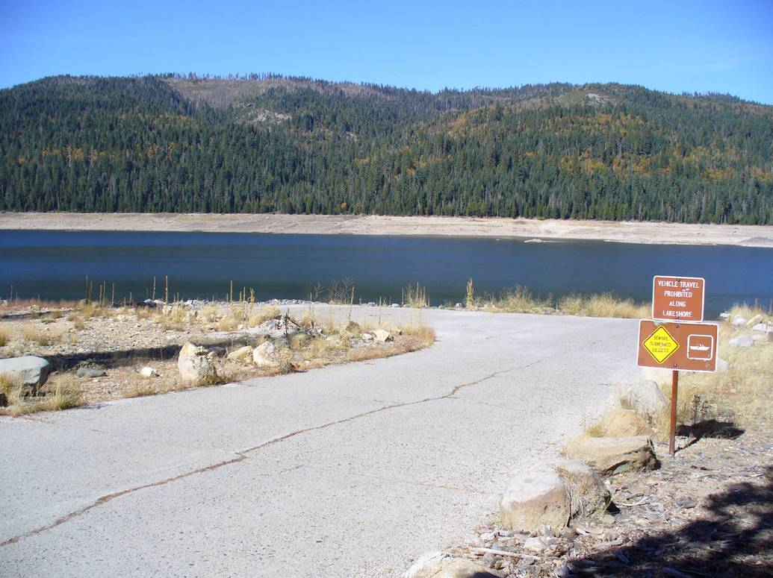
Low WSE Date: 10/24/08 Time:1153

French Meadows Reservoir Shoreline looking Northeast
from French Meadows Boat Ramp (KOP FM-5c)
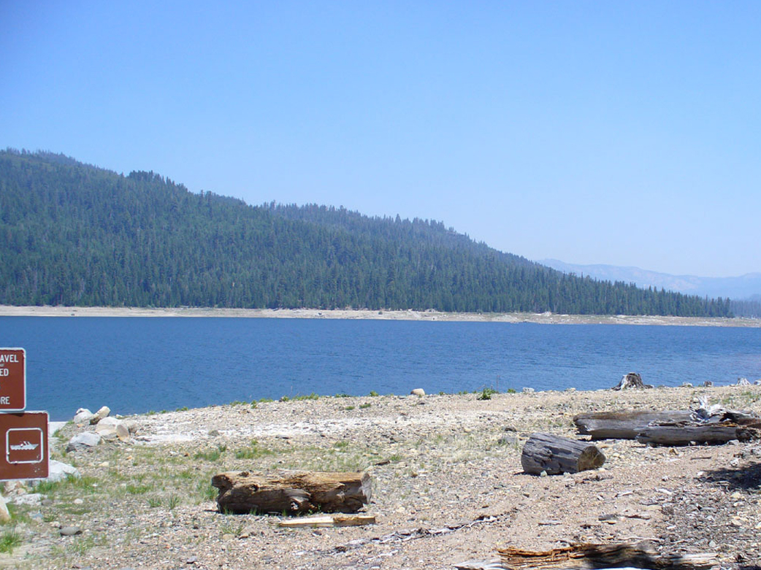
High WSE Date: 6/17/08 Time:1056
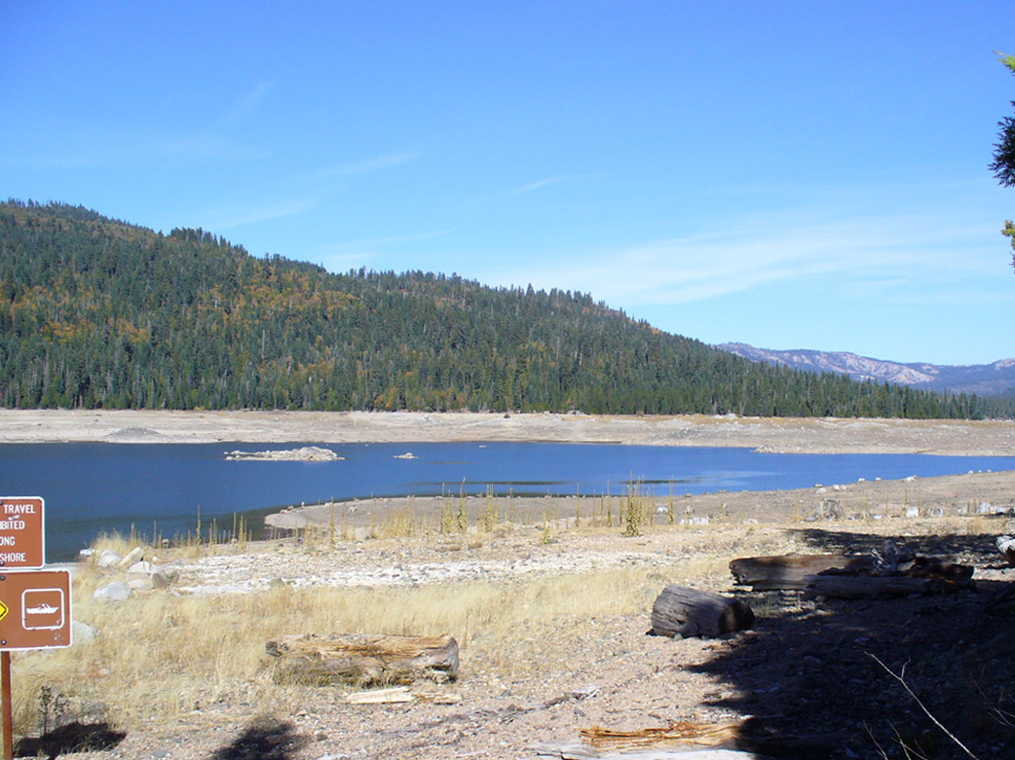
Low WSE Date: 10/15/07 Time:1154

French Meadows Reservoir Shoreline looking West
from McGuire Boat Ramp (KOP FM-6a)
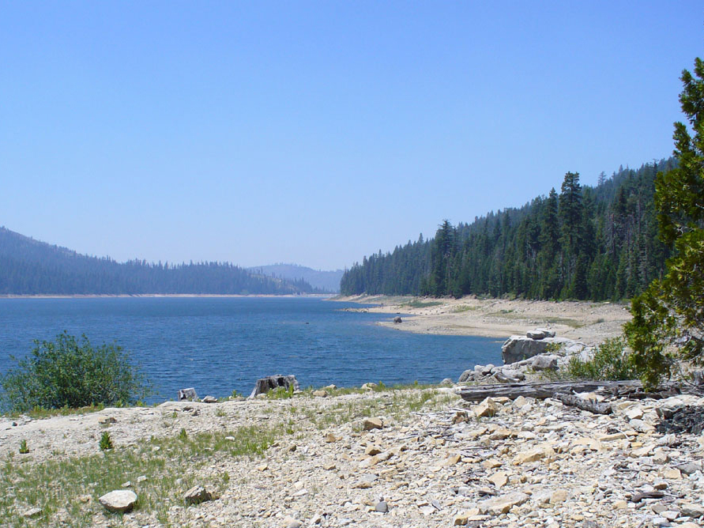
High WSE Date: 6/17/08 Time:1110
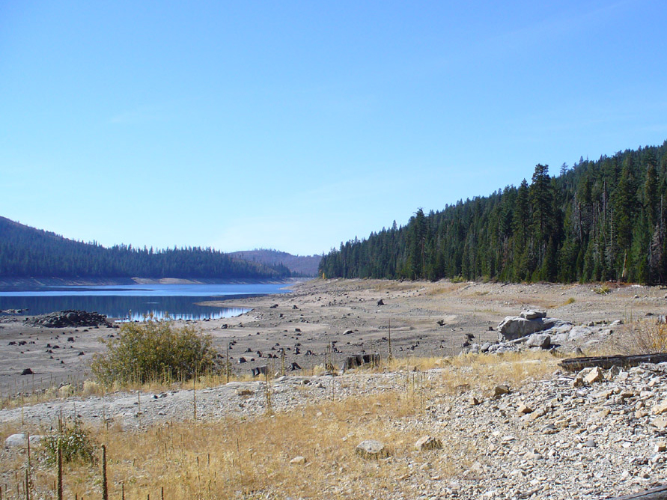
Low WSE Date: 10/24/08 Time:1137

French Meadows Reservoir Shoreline looking Southwest

from McGuire Boat Ramp (KOP FM-6b)
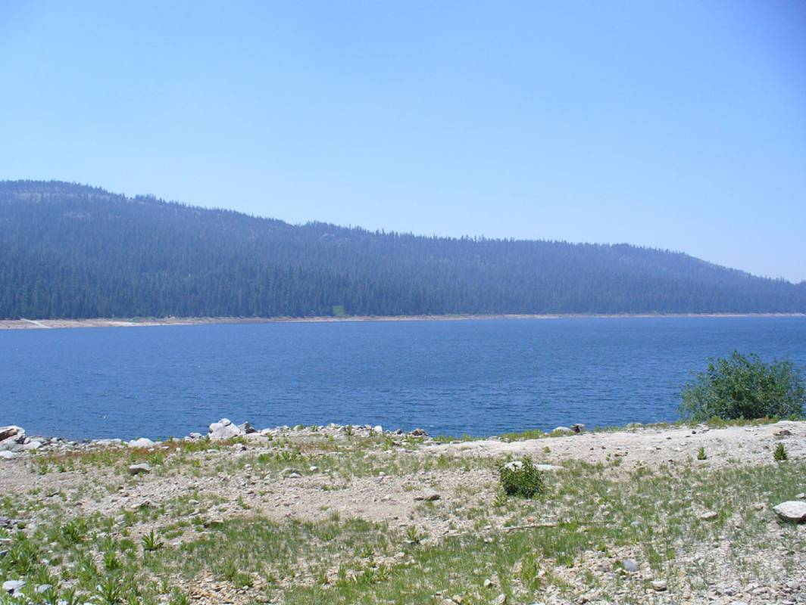
High WSE Date: 6/17/08 Time:1111
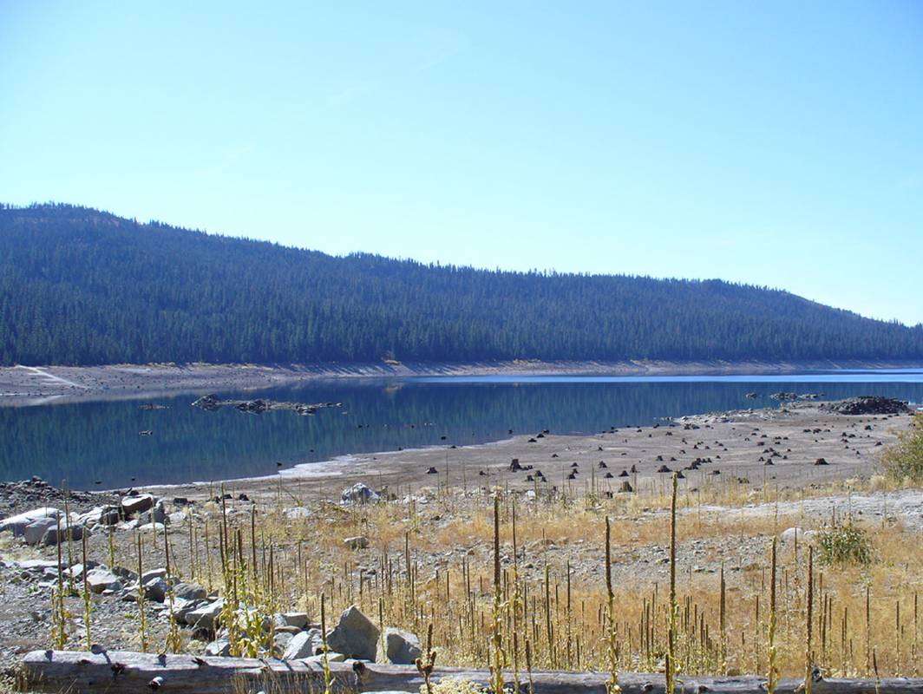
Low WSE Date: 10/24/08 Time:1139

French Meadows Reservoir Shoreline looking Southeast

from McGuire Boat Ramp (KOP FM-6c)
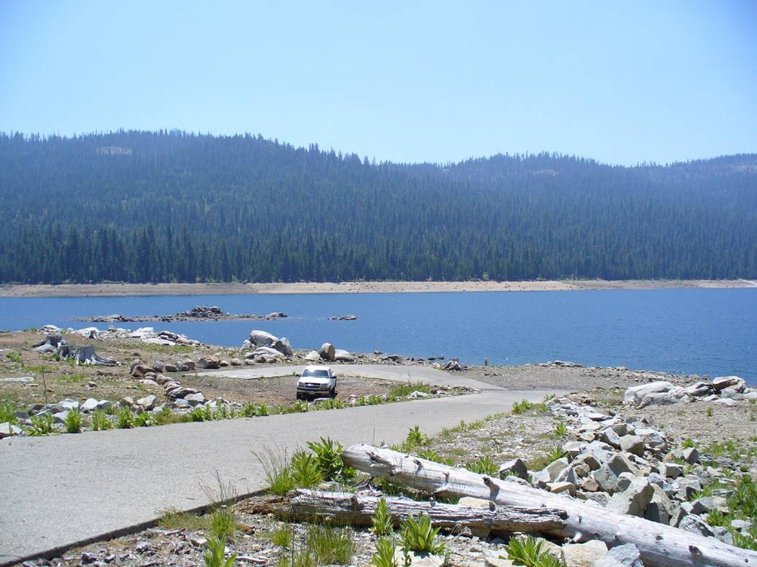
High WSE Date: 6/17/08 Time:1112
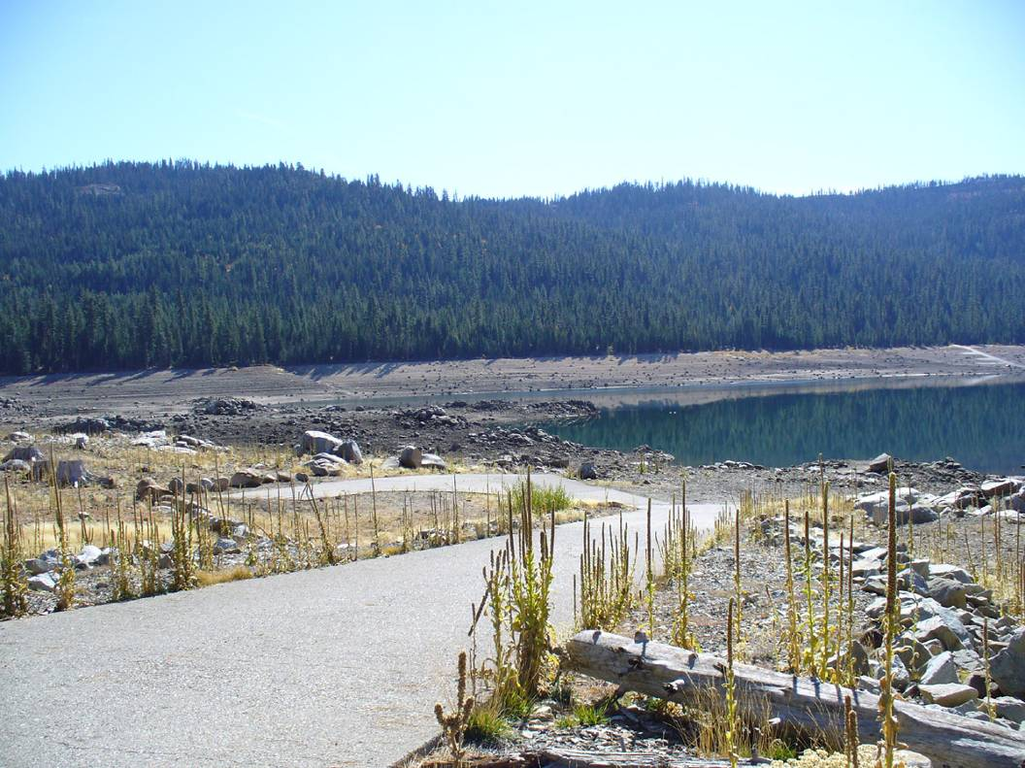
Low WSE Date: 10/24/87 Time:1139

French Meadows Reservoir Shoreline looking East

from McGuire Boat Ramp (KOP FM-6d)
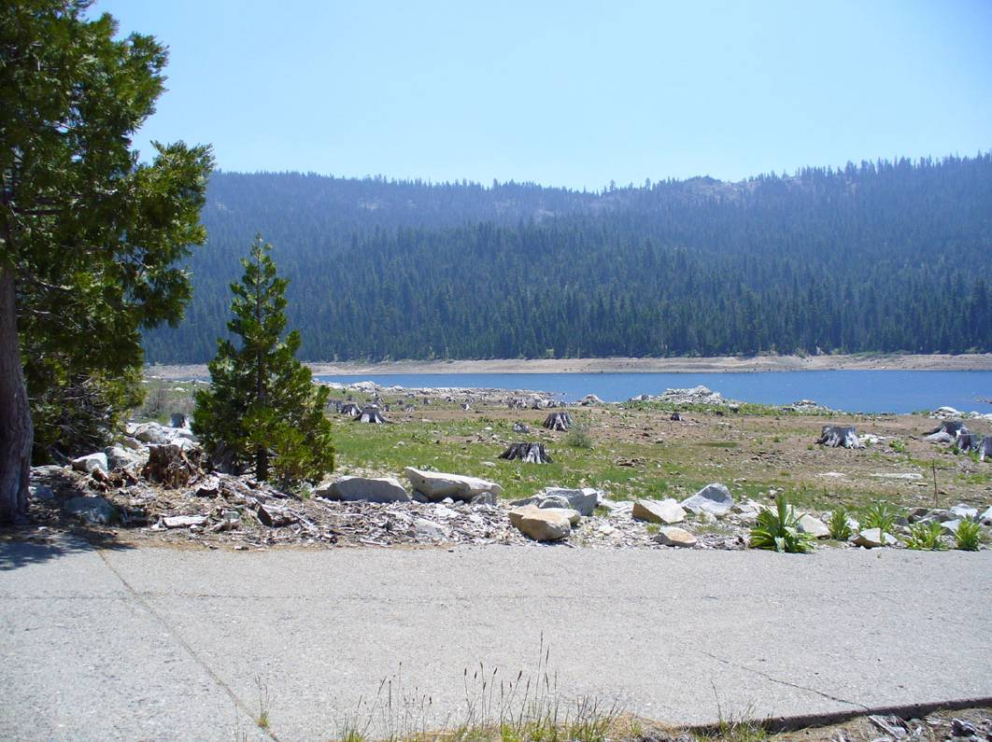
High WSE Date: 6/17/08 Time:1114
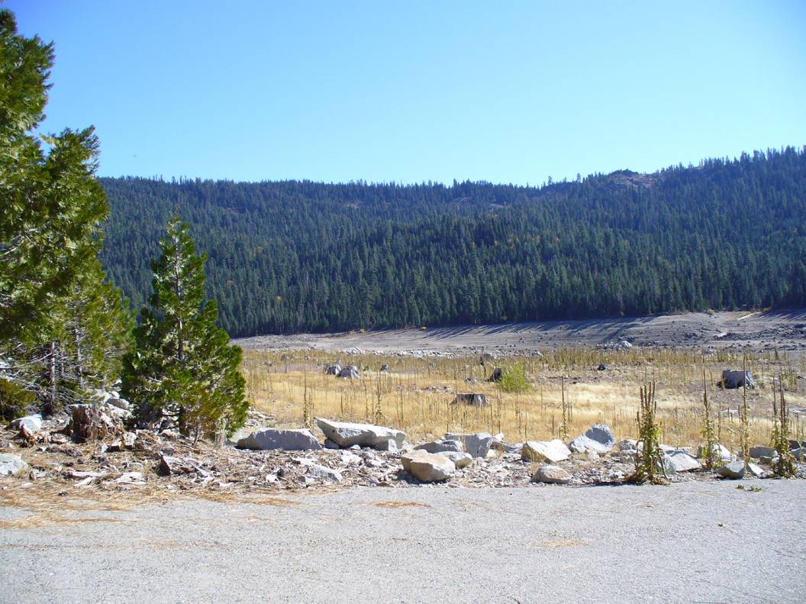
Low WSE Date: 10/24/08 Time:1141

